# TITLE PAGE

**SIMULATION AND IMPLEMENTATION OF A TRIPPLE VARIABLE DC POWER SUPPLY WITH USB PORT**

**by**

**salihu abdullahi**

**st/phy/hnd/21/001**

**A PROJECT SUBMITTED to the department of applied physics, federal polytechnic, mubi, ADAMAWA STATE**

**IN PARTIAL FULFILLMENT OF THE REQUIREMENT FRO THE AWARD OF HIGHER NATIONAL DIPLOMA (hnd) IN PHYSICS WITH ELECTRONICS**

**SEPTEMBER, 2023**

# DECLARATION

i declare that this project was written by Salihu Abdullahi and it is a record of my own Simulation and Implementation base research work. It has not been presented before in any previous application for the award of HND. References made to published literatures have been dully acknowledged.

Salihu Abdullahi ______________

(st/phy/hnd/21/001) SIGN/dATE

# CERTIFICATION

This is to certify that this project work on Simulation and Implementation of Triple Variable D.C. power supply, was done by Salihu Abdullahi ST/PHY/HND/21/001 and presented during the 2022/2023 academic session in the department of Physics and Applied Science Technology, Federal Polytechnic, Mubi.

Mr. Sabo Tantaso ______________

(Project Supervisor) Sign/Date

Mr. Sabo Tantaso ______________

(Head of Department) Sign/Date

Mr. Romanus I. O. ______________

(Project Coordinator) Sign/Date

_____________________ ______________

(External Examiner) Sign/Date

# DEDICATION

i dedicate this project work to God Almighty for enriching knowledge to carryout this project. Also, to my family and those who help in the struggle.

# ACKNOWLEDGEMENT

I show my profound gratitude to the Head of Department physics and applied science technology Mr. Sabo Tantaso who is also my project supervisor, for being faithful and diligent in his work, supervising and guiding me throughout my project work despite his numerous engagements.

Also, my sincere appreciation and thanks goes to the departmental project coordinator Mr. Romanus Ikechukwu Odii. for his assistance and advice academically.

Moreover, I express my appreciation and gratitude to Mr. Kahlid Yunusa, Mr. Hussaini James, Mr. Sunday Ayegun and Mr. Zira Yakubu for their moral and encouraging advice towards the pursuance of our studies.

Finally, my special thank goes to all academic and non-academic staff of the department, who are not mentioned above for their contribution to the success of our studies.

# TABLE OF CONTENTS

TITLE PAGE i

DECLARATION ii

CERTIFICATION iii

DEDICATION iv

ACKNOWLEDGEMENT v

TABLE OF CONTENTS vi

ABSTRACT viii

CHAPTER ONE 1

INTRODUCTION 1

1.1 Background of the Study 1

1.2 Statement of the Problem 2

1.3 Aim and Objectives 2

1.4 Significance of the Study 2

1.5 Scope and Limitation 3

2.1 Review of Related Literature 4

2.2.1 Digital Controlled Power Supply 5

2.2.2 Variable Power Supply Using 25volts AC Transformer 5

2.2.3 Linear Power DC Power Supply 5

2.2.4 Stabilize Variable power Supply (1 to 6volt DC) 5

2.2.5 Construction of 1 to 15volt Power Supply 6

2.2.6 DC Power Supply Using Lm7815 6

2.2.7 DC Power Supply Using BJT Series 7

2.2.8. DC voltage multiplier 7

2.2.10 Theraja B. L. and Thereja A. K. (2005), three phase D.C. power supply 8

2.2.11 Uchenna (2010) Demonstration of variable D.C. power supply. 8

2.3.2 Rectifier 10

2.3.3 Smoothing (Filter) 10

2.3.4 LM317 Pinout 11

2.3.5 Display Unit 12

CHAPTER THREE 13

3.1 Material and Method 13

3.1.1 List of material 13

3.2 Circuit Block Diagram 14

3.3.5 Bridge Rectifier 16

3.4 Circuit Diagram 17

3.4.1 Circuit Analysis 17

3.5 Simulation procedure 19

3.6 System implementation 19

3.7 Circuit operation 20

3.8 Casing 21

3.9 Circuit layout 21

CHAPTER FOUR 22

TESTING, RESULT AND DISCUSSION 22

4.1 Testing 22

4.2 Result 25

4.3 Discussion 25

CHAPTER FIVE 26

SUMMARY, CONCLUSION AND RECOMMENDATIONS 26

5.1 Summary 26

5.2 Conclusion 26

5.3 Recommendations 26

REFERENCES 27

# ABSTRACT

*A digital variable D.C. power supply provide an accurate adjustable source of electrical power the device has both analog and digital component. The variation of the voltage is done by some analog circuit while the display is done by the digital circuit. The digital D.C. power supply fixed the need by varying its output voltage to the required value by the use of potential divider system the device can be used for more than one purpose and many areas of application where D.C. voltage is required from 1 to 40 volts.*

# CHAPTER ONE

# INTRODUCTION

## 1.1 Background of the Study

Development in the field of electronic have provided different technological approach used for upgrading and improving the standard of D.C. voltages. Communication instrumentation control etc., electronics perhaps more than any other field of technology, has enjoyed an explosive development. Generally, in electronics all electrical instrument and circuit require a source of direct current (D.C.), power before they operate. This can be either from a battery or conventional D.C. source.

A power supply is a device that supplies electrical energy to one or more electric load. The term is most commonly applied to device that convert another form of energy to electrical energy, all electronic circuit from simple transistor and OP – amp circuit to elaborate digital microprocessor system requires one or more source of D.C. voltage. Simplest supply is a D.C. battery, it is not an ideal one as tis terminal voltage change in accordance with the load due to its internal resistance. Electronic component requires D.C. supply that is well regulated with low noise characteristics and provide a fast response to load change.

Regulated power supply is one that control the output voltage to a specific value. The controlled value is held nearly constant despite variation in either load current or voltage supplied by the power supply energy source (Hoftman, 2013).

The primary function of a power supply is to convert electric circuit from a source to the correct voltage, current and frequency to power the load. Some power supplies are separate stand alone pieces of equipment, while others are built into the load appliance that they power other function that power supplies may perform including limiting the current drawn by the load to safe level. Shutting off the current in the event of an electrical fault, power conditioning to prevent electronic noise or voltage surges on the input from reaching the load and storing energy so it can continue to power the load in the event of a temporary interruption. With today technology different type of electrical and electronic product continue to emerge and those products require either a very low or different voltage rating for their operation (Adejumobi, 2020).

The important variable power supply has a power input which receive energy form the energy source and a power output that deliver energy to the load, the input and output of this device consist of electronic connectors or hardware circuit connection. The variable power supply mainly compose of transformer is used to step down the A.C. voltage to the required level to the rectify. Rectifier converts the A.C. voltage to D.C. voltage either in halfwave or full wave rectification. A large value electrolytic capacitor is used for smoothing while a regulator is used for regulation and varying the voltage (Abidine, 2010).

## 1.2 Statement of the Problem

Some electronics appliance normally use battery as power supply. Other D.C. source has fixed output, instead of using batteries which have limited life time and fixed output. A variable D.C. power supply can be used which is been implemented as digital variable power supply (triple) the output voltage can be varied as required by the user and displayed on the display unit.

## 1.3 Aim and Objectives

The aim is to simulated and implement a triple power supply to provide the required power load using an A.C. supply at the input and to obtain variable regulated power from 1 to 40 volt at the output terminal and display the value on screen by turning the potentiometer. Specific objectives to be achieved are:

1. To put into practice the theoretical aspect of electronic told in class to solve problems.
2. To provide an electronic device that serve more than one purpose.
3. To eradicate frequency use of multimeter in measuring output voltage
4. To provide a device that can be used in various types of application.

## 1.4 Significance of the Study

This work will allow the supply of different voltages using a single power supply. That means a user will not require different power supplies of different voltage rating to power up different electronic of different voltage rating. The system is cost efficient as all the component used can easily be obtained in any electronic hardware at cheaper rate.

## 1.5 Scope and Limitation

The scope of the study is conversion of A.C. voltage to D.C. voltage to be displayed and it is limited to 1 to 40 volts.

**CHAPTER TWO**

**LITERATURE REVIEW**

## 2.1 Review of Related Literature

Thomas Edison invented direct current in the late 1870s and in 1920s crude device were first developed to serve as battery eliminators to power radios in both commercial and consumer market. The market for separate power supplies rise around 1929, where most radios manufactured include a built-in power supply. The need for standalone power supply remained relative from 1930 to 1940 (Charles, 2021). In the early 1950s and early 1960s power supply produced adopting may-Amp technology satisfy the application at this time vibrators converts and an automobile 12volt high voltage D.C. by mechanically switching (Paul, 2022).

Thermion (vacuum tube) diodes and solid state (semiconductor) diodes were developed separately, at approximately the same time, in the early 1900s, as radio receiver detectors. Until the 1950s vacuum tube diodes were more often used in radios because semiconductor alternatives (Cat’s Whiskers) were less stable, and because most receiving sets would have vacuum tubes for amplification that could easily have diodes included in the tube (for example the 12SQ7 double-diode triode), and vacuum tube rectifiers and gas-filled rectifiers handled some high voltage/high current rectification tasks beyond the capabilities of semiconductor diodes (such as selenium rectifiers) available at the time (Robert, 2004).

Battery-base, battery-linear and linear power supply those that the most common once (Green, 1995).

Paul (2022), constructed a DC power supply using 100kso and 50kso resistor which can be expected to obtain 3volts at the output but due to the resistance of the DC resistor used cannot be able to obtain that result instead he got 1.2volts, he used discharge and made no effort in retrying to solve the problem.

## 2.2.1 Digital Controlled Power Supply

A group of researchers conducted a study for the design and development of a simple but efficient digitally controlled regulated power supply of a variable voltage ranging from 0V to 15V with a maximum output current of 5A. The researchers’ approach employed on the paper is an embedded system designed around an intelligent microcontroller provided with a digitized reference voltage to control the input and the output liquid crystal display for the provision of greater precision, stability, and accurate results of their experiments (Shoewu, Olaniyi & Ogunley, 2022).

## 2.2.2 Variable Power Supply Using 25volts AC Transformer

Kepco (2021), construction of a DC power supply using 25volt transformer, He was expecting to get 12 volts at the output but instead he got 7.5volt DC at the output. The resistance of the voltage selector and other hardware used in the construction drain the voltage. Due to this problem encounter by Benjamin, He again constructed the same device but using only to voltage sector, with this he obtained 9volt at the output. But he was able to achieve the required voltage at the output.

## 2.2.3 Linear Power DC Power Supply

Benyon (2019), construction of a linear power supply using half wave rectification in his construction the AC voltage is being rectified using one diode. This type of rectifier only allows one half-cycle of an AC voltage to DC voltage. This half wave rectifier is nothing more than a single PN junction diode connected in series to the load resistor that allows electric to flow in only one direction. This type of power supply is unregulated, the DC terminal is affected significantly by the amount of load, this is the major setbacks to this type of power supply as the loads draws more current the terminal voltage becomes less.

## 2.2.4 Stabilize Variable power Supply (1 to 6volt DC)

Adedayo Adelakum (2014), the main purpose of this work is to construct a stabilize variable power supply unit with a voltage range of 1 to 6volts and also study the regulating characteristics of a constructed power supply unit to a certain load and line regulation so as to determine its stability by comparing it to a standard power supply unit to power load (Rheostat of 126ohm 0.5A) the major component used include transistor regulator the output measurement showed that the power supply was functional and the measured value gave minimal variation from the standard value. This type of power supply is used where low voltage is required from 1 to 6volt DC

## 2.2.5 Construction of 1 to 15volt Power Supply

Naman Saini (2020), construction of 1 to 15volt power supply, here the main working principle of this project is full of wave rectification which is done by bridge configuration, using 4 diode and those rectifies the output of the step-down transformer which step down the 220volt AC to 12volt AC, in this circuit two capacitor c1and c2are used to get constant input to the regulator of 12volt. Moreover, it also helps to reduce the sharp peaks in the output a 2200uf and 470uf capacitors are used to reduce the noise and ripples produced by the regulator so that the regulator output has less ripples. The main task of this circuit is to get variable output and for this a pair of voltage divider resistor variable resistor of 1kso and 5kso to increase the output of the regulator and in which resistance is varied so by increasing or decreasing the value of the resistor the output voltage of the regulator will also change accordingly and 1 to 15volt is obtained at the output terminal.

## 2.2.6 DC Power Supply Using Lm7815

Amadi (2020) constructed as 15volt DC power supply using I.C Lm7815 in his work a step-down transformer of 15volt was used and a bridge rectification using four diodes to rectify the AC voltage while a smoothing capacitor of 1000uf 25volt was used. The regulating I.C Lm7815 has three terminal pin1 pin2 and pin3. Pin1 is the DC input terminal while pin2 is the ground terminal of the integrated circuit which is connected to a bias resistor and a ziner diode to the ground and the pin3 is the voltage output terminal to the load an output couplay capacitor is connected across the positive and negative terminal of the output. The voltage at the output can be measured using multi meter, the main drawback of this work was that the power supply is not variable and there is no display on the system.

## 2.2.7 DC Power Supply Using BJT Series

John (2020) constructed a variable power supply 1.5 to 9volt DC using bipolar junction transistors series, the construction was made with 12volt AC transformer to step-down the voltage to require value full wave rectification using four diodes, a series of ten capacitors is connected in series at a resistor, across the work six BJT transistors are connected according to the design of the hardware component. The voltage appears at the output in different steps. The major setback of this type o power supply is that the voltage is obtained at different terminals.

## 2.2.8. DC voltage multiplier

Simon (2022) constructed a voltage multiplier this type of D.C voltage the D.C output is greater than the A.C input the circuit is constructed using several IN 400l diode connected in series the A.C main source live terminal is connected to positive terminal of the capacitor which the negative terminal of the capacitor is connected to cathode terminal of the diode D1 and D1 is connected to D2 and D2 is connected to D3+……….. which the neutral terminal of the A.C. source is connected to the anode of D1 which is connected to C2, in this circuit 12 diode is connected in series which 12 capacitors of same value. D.C voltage multiplier are required in application when is necessary or high voltage is required with low current as for electron acceleration purpose in cathode ray tube this type of D.C power supply is not suitable for low voltage application.

2.2.9 a Basu *et al.* (2002), have introduce power quality improvement techniques and solution the problems can be viewed as the difference between the quality power supplied and the quality of the power required for reliable operation of the load equipment using this viewpoint the quality problem can be resolved in to one of this three ways listed as follow

1. Reducing the power supply disturbance
2. Improving the load equipment immunity to disturbance
3. Inserting correct equipment between the electrical supply and the sensitive load

## 2.2.10 Theraja B. L. and Thereja A. K. (2005), three phase D.C. power supply

In this construction the D.C. rectifier of a 3-phase supply with help of a diode along with a smoothing circuit. The three diodes are connected to the three phase of star-connection secondary of a 3-phase transformer. Neutral point N of the secondary the negative terminal for the rectified output and is earthed.

## 2.2.11 Uchenna (2010) Demonstration of variable D.C. power supply.

The demonstration of D.C. power supply work by Uchenna is a construction of stabilized power supply unit with a voltage range from 1 – 20 volts D.C. with a low output impedance, he studied the characteristics of a constructed power unit which he ascertained the load and line regulation. The test and analysis were carried out using the constructed power supply unit to power a load. In this construction an external measuring device is required to determine the quantity of the output magnitude, he used both analog and digital meter during his test due to the fact that there is a slide variation between the two meter used the analog meter showed 18.6 volt D.C. while the digital meter showed 20 volt D.C. the casing of the device is metal and in square shape.

**2.3 Some components used**

**2.3.1 Transformer**

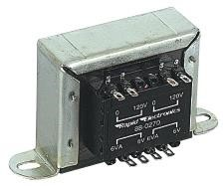

Figure 2.1: Transformer

A Transformer is an equipment used either for raising or lowering the voltage of an ac supply with a corresponding decrease and increase in current. It essentially consists of two windings primary and secondary.

N1 = no. of turns in primary coil

N2 = no. of turns in secondary coil

N1< N2 = Step-up transformer

N1> N2 = Step-down transformer

Transformers convert AC electricity from one voltage to another with little loss of power. Transformers work only with AC and this is one of the reasons why mains electricity is AC.

Step-up transformers increase voltage, step-down transformers reduce voltage. Most power supplies use a step-down transformer to reduce the dangerously high mains voltage (230v) to safer low voltage.

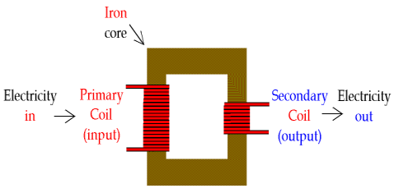

Figure 2.2: Transformers and their symbol

The input coil is called the primary and the output coil is called the secondary. There is no electrical connection between the two coils, instead they are linked by an alternating magnetic field created in the soft-iron core of the transformer. The two lines in the middle of the circuit symbol represent the core.

Transformers waste very little power so the power out is (almost) equal to the power in. Note that as voltage is stepped down current is stepped up.

The ratio of the number of turns on each coil, called the turn’s ratio, determines the ratio of the voltages. A step-down transformer has a large number of turns on its primary (input) coil which is connected to the high voltage mains supply, and a small number of turns on its secondary (output) coil to give a low output voltage.

## 2.3.2 Rectifier

There are several ways of connecting diodes to make a rectifier to convert AC to DC. The [bridge rectifier](http://www.kpsec.freeuk.com/powersup.htm#bridgerectifier) is the most important and it produces full-wave varying DC. A full-wave rectifier can also be made from just two diodes if a centre-tap transformer is used, but this method is rarely used now that diodes are cheaper. A [single diode](http://www.kpsec.freeuk.com/powersup.htm#singlediode) can be used as a rectifier but it only uses the positive (+) parts of the AC wave to produce half-wave varying DC.

## 2.3.3 Smoothing (Filter)

Smoothing is performed by a large value [electrolytic capacitor](http://www.kpsec.freeuk.com/components/capac.htm#polarised) connected across the DC supply to act as a reservoir, supplying current to the output when the varying DC voltage from the rectifier is falling. The diagram shows the unsmoothed varying DC (dotted line) and the smoothed DC (solid line). The capacitor charges quickly near the peak of the varying DC, and then discharges as it supplies current to the output.

Smoothing is not perfect due to the capacitor voltage falling a little as it discharges, giving a small ripple voltage. For many circuits a ripple which is 10% of the supply voltage is satisfactory and the equation below gives the required value for the smoothing capacitor. A larger capacitor will give less ripple. The capacitor value must be doubled when smoothing half-wave DC

So, in this we concluded that the pulsating DC voltage is applied to the smoothing capacitor. This smoothing capacitor reduces the pulsations in the rectifier DC output voltage.

## 2.3.4 LM317 Pinout

The LM317 Voltage Regulator has 3 pins. Below is the pinout:

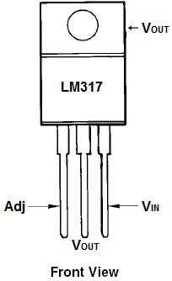

LM338

Figure 2.3: LM338 Pinout

Looking from the front of the voltage regulator, the first pin (on the left) is the Adjustable Pin, the middle is Vout, and the last pin(on the right) is VIN.

**VIN -** VIN is the pin which receives the incoming voltage which is to be regulated down to a specified voltage. For example, the input voltage pin can be fed 12V, which the regulator will regulate down to 10V. The input pin receives the incoming, unregulated voltage.

**Adjustable -** The Adjustable pin (Adj) is the pin which allows for adjustable voltage output. To adjust output, we swap out resistor R2 value for a different resistance. This creates adjustable voltages.

**VOUT -** VOUT is the pin which outputs the regulated voltage. For example, the LM317 may receive 12V as the input and output a constant 10V as output.

Output from the full wave bridge rectifier is fed to a LM317 regulator IC LM317 provides varied voltage from 1.2V to 35V. Reference voltage of 1.25 V is maintained at 220 Ohm Resistor.

The LM317 Voltage Regulator is a 3-terminal [adjustable voltage regulator](http://www.learningaboutelectronics.com/Articles/What-is-an-adjustable-voltage-regulator) which can supply an output voltage adjustable from 1.2V to 35V. It can supply more than 1.5A of load current to a load.

## 2.3.5 Display Unit

The display unit is a module consisting of microchip and other components. This circuit convert the analogue signal to digital signal and display the value being measured in digital form (Numeral). The major advantage of this system is the reading of the value being displayed is easy and accurate unlike analogue display.

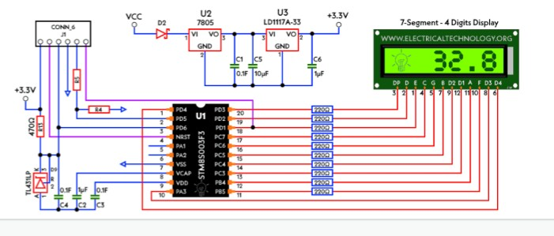

Figure 2.4: Display unit

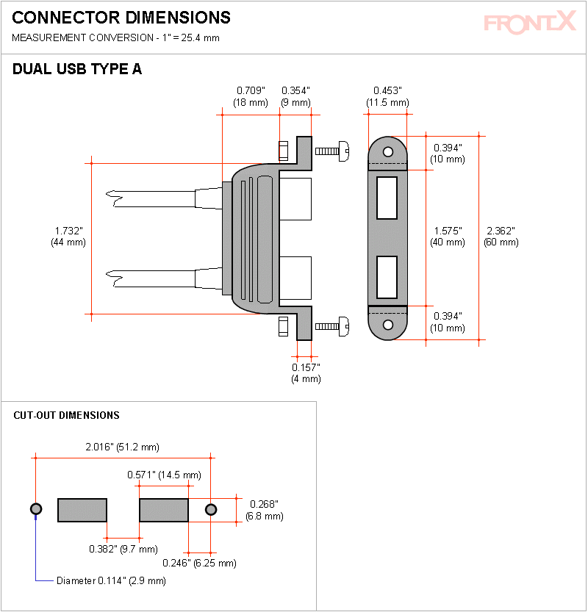

Figure 2.5: Dual USB Type A port

# CHAPTER THREE

## 3.1 Material and Method

The material for the project are both active and passive electronic component. Most of the component used for this project are available, and the analog to digital converter is a module which will be connected to the constructed circuit.

## 3.1.1 List of material

|  |  |  |  |
| --- | --- | --- | --- |
|  | **Name** | **Value** | **Quantity** |
| 1 | Analog to Digital Converter | DT830D | 1 |
| 2 | Transformer step down | 240 50Hz 24 or 30V 3000 MA | 1 |
| 3 | Diode | IN 4001 | 6 |
| 4 | Capacitor | 2200uf 50V | 1 |
| 5 | Capacitor | 10uf 63V | 1 |
| 6 | Capacitor | 0.1uf | 1 |
| 7 | capacitor | 470uf 50V | 1 |
| 8 | Variable resistor | 10Kso | 1 |
| 9 | Resistor | 2.2kso 1watt | 1 |
| 10 | I.C | Lm 317 | 1 |
| 11 | Resistor | 1ks0 | 1 |
| 12 | LED | Red | 1 |
| 13 | Vero board | Copper lines | 1 |
| 14 | Connectors | Many | many |

## 3.2 Circuit Block Diagram



**AC supply**

**230**

**v/50hz**

**Transformer**

**(**

**step**

**-**

**down)**

**Diode**

**Rectifier**

**Filter**

**Circuit**

**Voltage**

**Regulator**

Display Unit

Figure 3.1: Circuit Block Diagram

**3.3 System Description**

**3.3.1 Hardware Analysis**

**3.3.2 Transformer**

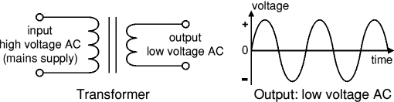

Figure 3.2: Transformmer

Implementing the power supply to the following specification

Transformer current 500mA = 0.5A

Transformer input voltage A.C. Power supply 220V A.C.

Transformer output voltage 14Volt A.C.

Assuring the voltage drop in transformer coil to be 0.7v

Vrms = 0.7 x 21.99 = 15.45

The transformer rating

Im x Vrm

0.5x15.4 = 7.7V/a

**3.3.3 Rectifier Analysis**

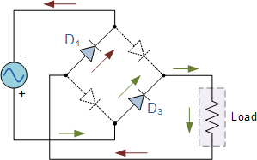

Output of

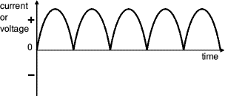

Figure 3.3: Resultant wave form

The power unit using a full wave rectifier determining the resultant maximum voltage from the rectifier.

Vmax

Vdc =

Vm =

Vm = = 21.99

Vm = 21.99

**3.3.4 Choice of Diode use**

Vmax x 2

Therefore, 21.99 x 2 = 43.98

Pv = 44 VDC

A diode that can handle 44VDC is used 1N4001 series

The power unit using a full wave rectifier determine the resultant maximum voltage from the rectifier.

Vmax

Vdc =

Vm =

Vm = = 21.99

Vm = 21.99

## 3.3.5 Bridge Rectifier

A bridge rectifier can be made using four individual diodes, but it is also available in special packages containing the four diodes required. It is called a full-wave rectifier because it uses all the AC wave (both positive and negative sections).

**The Positive Half-cycle**. During the positive half cycle of the supply,

diodes D1 and D2 conduct in series while diodes D3 and D4 are reverse biased and the current flows through the load as shown below.

The Negative Half-cycle During the negative half cycle of the supply, diodes D3 and D4 conduct in series, but diodes D1 and D2 switch “OFF” as they are now reverse biased. The current flowing through the load is the same direction as before.

Hence, we can say that the bridge wave rectifier give the pulsating DC voltage which are not suitable for electronics circuit.

**3.3.6 Choice of Capacitor**

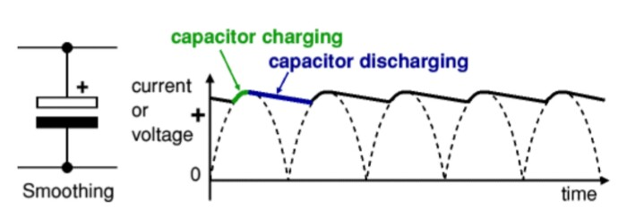

Figure 3.4: Regulated Output Smoothing

For the value of capacitor being used in the implementation, the value of smoothing capactor is given by;

R1 =

Vdc = 44

1dc = 0.5

R1 = 88

R = Ripple factor

L = Load resistance

C = capacitor

Ripple factor = = 0.1

C = = 1232

= 1232 microfarad

1200 micro farad was selected for the smoothing

## 3.4 Circuit Diagram

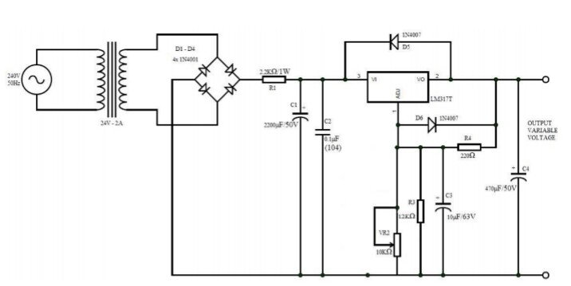

Figure 3.5: Circuit Diagram

## 3.4.1 Circuit Analysis

Using LM317 with resistors

Vmax = Maximum voltage

Vmin = Minimum voltage

For Voutmax = Vref

For the circuit

Vref = 1.25

R3 = 12K

R4 = 220

Rv = 16K at maximum

Using R =

The output voltage of LM317

Voutmax = 1.25

Rv Max 16K

Therefore,

1.25 = 1.25

= 1.25 = 1.25 = 40.25

Vout max = 40.25 V.D.C.

For Vout minimum the resistor is turn to less than one

Rv = 0

Vout min = 1.25

= 1.25

= 1.25 = = 1.25

= 1.25 V.D.C.

**Ripple factor of the build circuit at 100% resistance and at 0% resistance**

Ripple factor at 100% Resistance

% r = x 100

% r = x 100

% r = x 100 = 4.955Nv

at 100% r = 0.000005%

Ripple factor at 0% Resistance

% r = x 100

% r = x 100%

% r = 2.725 x 100%

% r = x 100%

0.0002725%

The calculated resistance shows that the ripple factor at 0% 0.000273 and at 100% is 0.000005% both result has value to 0, which means the build circuit is a variable power supply.

## 3.5 Simulation procedure

The implemented circuit was simulated using software windows platform, all components and parameters were chosen form the database. The simulation was done under five setting.

1 No A.C. Input

2 With A.C. Input

2.1 Circuit is started

2.2 Display unit started

2.3 The voltage and process

2.4 Simulation started

With the simulation running the nob which are represented by variable resistor are set at different point by using the mouse.

## 3.6 System implementation

The implementation of digital variable power supply was made using necessary procedure. The components were mounted on bread board to test whether its working perfectly and later transferred to the Vero board to form a closed circuit, the component are connected to one another and linked in a stage to a complete circuit in accordance to the circuit diagram, the arrangement and the connection of those component that can not be mounted on a board and addition of some connections to aid the functions ability of the circuit were included. After the components have been laid on the Vero board it was checked and rechecked for faulty replacement, then with point tip and a good soldering iron lead, the connection of the components were soldered on to the Vero board carefully. After soldering process, the board was carefully examined so that there will be no bridge of lines or components during the soldering process and to check for partial contact, some of the necessary tools used during the method implementation are

1. Multimeter
2. Soldering iron
3. Soldering lead
4. Pair of small cutter etc.

## 3.7 Circuit operation

The 220volt A.C. coming from the power cord is fed to the transformer via the on-off switch and the 500mA fuse. The 40volt (approximately) from the transformer goes to the bridge rectifier where it is converted from A.C. to D.C. volt. The IN 4001 was used for the bridge (rectification) for converting the pulsation D.C. output from the rectifier via the 100µf capacitor and fed to input of the adjustable LM338 regulator. The output of this voltage from 1 to 40volt via the pin 2 and the 10K potentiometer p1, the large value of the capacitor C1, make good low ripple output voltage. The work of this regulator is to compare the output voltage to an internal reference and control the output voltage so that it remains constant. The IC also provides a method of adjusting the output voltage to the level required by using the potentiometer. Internally the regulator uses a diode to provide a fixed reference voltage of Ov across the external Resistor R1 and the potentiometer P1 increase the resistance voltage across it due to the current from the regulator plus current from R2 its voltage increase. D1 is a general purpose 1N4001 diode is used as a feedback blocker steer any current that might come from the diode under power around the regulator to prevent the regulator from being damaged.

## 3.8 Casing

The successful implementation of this work would not be completed without a casing for it of which would protect the system from human and environmental hazards like direct sun rays and moisture, over the years, wooden or metallic casing were used for the project but careful analysis showed that metallic casing are better than the wooden type with modern technology developing in doping material, a more durable light and thermoplastic in nature is employed, this does not conduct electricity or electric charges. The plastic case was made for the project, the top view has the display unit and the variable resistor knob, the power supply cable is placed at the side. The casing is in rectangular shape.

## 3.9 Circuit layout

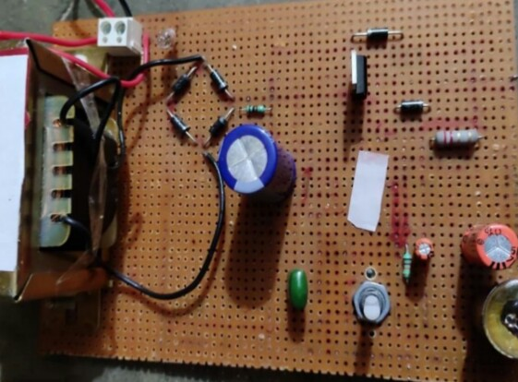

Figure 3.6: Circuit Layout

# CHAPTER FOUR

# TESTING, RESULT AND DISCUSSION

## 4.1 Testing

Simulation of the major component implemented in the project was subjected to test at the end of the implementation during the test value of component were varied and verify by the potentiometer in order to see the expected range of acceptable unit by unit is substituted within the model in a way to stress it capability of operating correctly in several manners. In order to be satisfy and see it normal application. The following simulations were carried out.

1. Its performance characteristics of major circuits such as transformer simulation, rectifier simulation, smoothening simulation which was shown in the figure of methodology.
2. To ascertain whether the board has flow following the short or open circuit.
3. To ascertain the stable or condition of the device.

Having been satisfied with the simulation of the project leads to a favourable outcome result. The required output voltage was achieved.

The transformer simulation was carried out to determine the characteristics which is shown in figure 3.1 which shows the output waveform: low voltage A.C. required. The second simulation is of fullwave rectifier system that is used int eh implementation which is shown in figure 3.2. this is the output varying D.C. the third simulation included all major component that is the transformer + Rectifier + Smoothing. Looking at the simulation output the smooth D.C. output has a small ripple shown in figure 3.4 and figure 3.5. The complete circuit simulation include transformer + Rectifier + Smoothing + Regulation shown in figure 3.6 and the display unit simulation in figure 3.7.

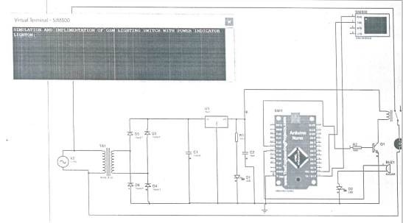

SIMULATION OF VARIABLE D.C. POWER SUPPLY WITH POWER ON



Figure 4.1: Simulation showing power ON

SIMULATION OF VARIABLE D.C. POWER SUPPLY WITH POWER ON

Figure 4.2: Virtual Booting status

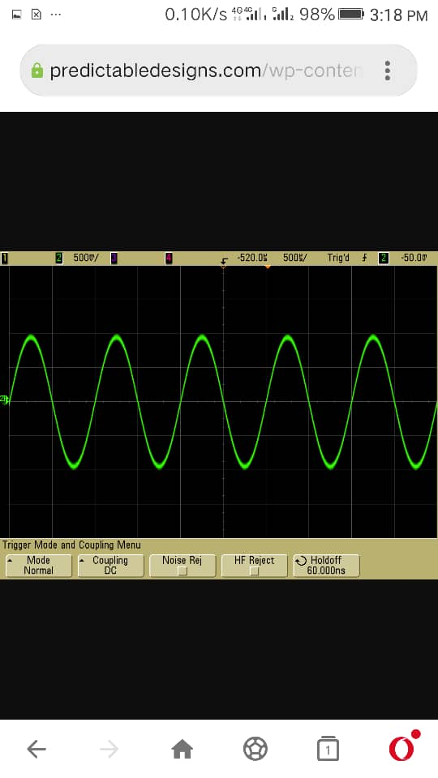

Figure 4.3 Transformer output waveform

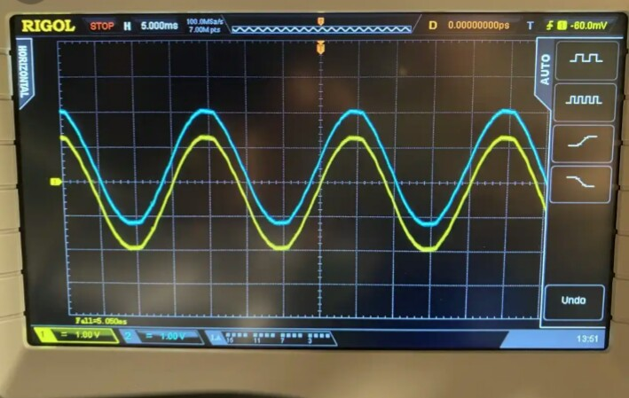

Figure 4.4: Waveform of dual transformer output

**4.1.2 Flowchart**

A.C. Voltage

Rectifier

Variable D.C.

Display

Output terminal

Figure 4.5: Flowchart

## 4.2 Result

The result obtained during the test is stated at the table below:

|  |  |  |  |
| --- | --- | --- | --- |
| **S/N** | **TEST** | **RESULT** | **COMMENT** |
| 1 | A.C. Main input to transformer | 220volt A.C. | Input to transformer |
| 2 | Rectifier input | 14volt A.C. | Transformer output to rectification |
| 3 | Rectifier output | 22volt D.C. | Rectification output to the terminal of capacitor C1 |
| 4 | Variable D.C. voltage 1 to 40 | 1 to 42 | D.C. variable at the output terminal |
| 5 | Vout Max | 40.25 | At the output terminal |
| 6 | Vout Min | 1 | At the output terminal |

## 4.3 Discussion

Here I made the implementation of a Digital D.C. variable power and the main working principle of this is a full wave rectification which is done by bridge configuration which has its input from the step-down transformer, the circuit used C1 and C2 in order to have a constant input to the regulator. The main task is to get variable output and for this a pair of voltage divider resistor was used by increasing or decreasing the value of that resistor, the output voltage of the regulator will also change accordingly. The test was carried out t ascertain the working principle and the desired voltage required at the output terminal was achieved from 1 to 40volt D.C.

The A.C. main voltage from the public power supply is 220V a.c., the transformer step-down in the table. The function of rectifier is to convert the a.c. conventional volatage a D.C. voltage as shown in the table above. The voltage is applied to the main circuit of LM317 with the combination of reistors both in parallel and in series connection. The voltage can be varied using variable resistor at maximum was obtained 40.25 and vout min 1 at the output terminal.

# CHAPTER FIVE

# SUMMARY, CONCLUSION AND RECOMMENDATIONS

## 5.1 Summary

The variable D.C. power supply utilizes a 220volt A.C. supply which is stepped down by the step-down transformer. The output of the transformer is feed to the bridge rectifier circuit the capacitor do the smoothing of the voltage which is rectified by the bridge rectifier after the smoothing the regulator takes the input from Vin pin the Vadj pin is connected to the potentiometer with a resistor and grounded and the regulated voltage output is on Vout pin with protective diode. The output voltage is connected to the output terminal and the digital display.

## 5.2 Conclusion

The aim of the project is to make the student adopt the theories told in class and put them into practical realization for the benefit of mankind. The circuit was implemented and tested; the output voltage as expected was achieved.

## 5.3 Recommendations

The project implementation has its limitation which are technical specification and finance.

The government through project related corporate bodies should help or finance department to provide some of the project materials.

Some project implemented should be kept and used in schools in various field of its application.

# REFERENCES

Adeife T.O & Osemekillali, O. (2020). *Electronic Engineering Fundamental voll*. Ademola printing press, Osogbo Osun State Nig.

Amadi, B. (2020). Seminar report presented to the department of Applied Physics, Taraba State University, Jalingo.

Benjamin, M. (2020). D.C. Power supply. *Engineering Journal of Innovation research in electronic instrumentation and control, 13*(2), 33-41.

Benyon, D. "What is a Power Supply Unit (PSU)?," 14 October 2019. [Online]. Available[:https://www.techbuyer.com/blog/What-isa-Power-Supply-Unit-PSU#:~:text=A%20Power%20Supply%20Unit%20( PSU)%20is,an%20internal%20IT%20hardware%20c omponent.&text=Specifically%2C%20a%20power%20supply%20converts,required%20for%20modern%20computing%20components](https://www.techbuyer.com/blog/What-is-a-Power-Supply-Unit-PSU#:~:text=A%20Power%20Supply%20Unit%20(PSU)%20is,an%20internal%20IT%20hardware%20component.&text=Specifically%2C%20a%20power%20supply%20converts,required%20for%20modern%20computing%20components)

Green, D.C (1995). *Electronic technology* 5th edition long man Scientific and technical long man group Ltd. Long burnt mull.

Hoftman, J. (2013). Power supplies and application. MacGraw Hill publisher, New York USA.

John, H. (2020). Power supplies electronics club, *International Journal of Advances in Applied Science Research, 4*(1):515-522.

KEPCO Inc., "A SHORT HISTORY OF THE EVOLVED POWER SUPPLY," [Online]. Available: [https://www.kepcopower.com/newsevo.ht m#:~:text=The%20power%20supply%20industry%2 0dates,a%20built%2Din%20power%20supply.](https://www.kepcopower.com/newsevo.htm#:~:text=The%20power%20supply%20industry%20dates,a%20built%2Din%20power%20supply) [Accessed 24 February 2021].

N. Saini, A. Sarama and R. Gupta, "VARIABLE DC POWER SUPPLY," ResearchGate, Srinagar, Uttarakhand, 2020.

Oluwagbemiga, O. M. Olaniyi and O. M. Ogunleye, "Design and Development of an Intelligent Variable Power Supply Device," The Pacific Journal of Science and Technology, pp. 30-37.

Paul, S. & Simon, M. (2022). Practical Electronics for inventors

Robert, L. & Louis, N. (2004). *Electronic Device and Circuit Theory*. Eight Edition, Prentice Hall of India Private Limited, New-Delhi

Study, M. (2022). *Design of a 0 to 12v regulated d.c power supply*. Retrieved March 27th 2022: from http:/www.sturdymafia.org./ps/30_contents.htm

Theraja, B.L and Theraja, A. K. (2002). *A Textbook of Electrical Technology*. 23rd ed.s. Chand: New Delhi, India.

Uchenna, O. (2022). Demonstration of variable power supply. A project report submitted to the department of physics Adamawa State University, Mubi.

WHAT IS A POWER SUPPLY, AND HOW DOES IT WORK?,” Advanced Conversion Technology. [Online]. Available: [https://www.actpower.com/educational/what-is-a-power-supply-and-how-does-it-work/.](https://www.actpower.com/educational/what-is-a-power-supply-and-how-does-it-work/) [Accessed: 25-Feb-2021].

Wavelength Electronics, "Power Supply Basics," Wavelength Electronics Inc., 2018. [Online]. Available: [https://www.teamwavelength.com/power-supplybasics/#:~:text=A%20power%20supply%20takes%2 0the,supply%20from%20the%20mains%20input.](https://www.teamwavelength.com/power-supply-basics/#:~:text=A%20power%20supply%20takes%20the,supply%20from%20the%20mains%20input). [Accessed 2 March 2021].

Wdwuard, I. (1995) *Electrical technology* 7th edition long man Singapore publisher P.T.O.

Zhang, H. Li and S. Li, "Multi-Channel Adjustable DC Power Supply with Single Transformer Based on Spectral Separation," Electrical Engineering, pp. 5054, 2014.